|  |
| --- |
| Econometrics Final Research Project |
| **Impact of Crude Oil prices, REER and Global Inflation on GDP Growth of Pakistan** |
| Submitted To: Mirza Aqeel baig |

|  |
| --- |
| **Bushra Hashmi (19966)**  December 26th , 2016 |

## TABLE OF CONTNET:

* Abstract
* Introduction
* Literature Review
* Data & Methodology
* Findings
* Results
* Conclusion
* Annexure A

***Abstract***

*This paper discussed the impact of crude oil prices on the Pakistan’s GDP during 1980 to 2015;* *Pakistan is not oil producing rather oil-importing country. An increase in oil price leads to inflation, increase budget deficit and puts downward pressure on exchange rate which makes imports more expensive. This study analyzes that, how change in real crude oil price, real effective exchange rate and global inflation effects the real GDP positively or negatively.*

***Key Words:***Crude Oil, Economic Growth

***Jel Classification:*** *Z10, P0, P1*

## 1. Introduction:

Till 1970 oil prices were around 1 $/ barrel. In 1973 with the consequences of famous oil embargo the oil prices shot up and reached up to 30 $/barrel. The prices remained turbulent due to political unrest in Middle East and reached above 100 $ presently oil is trading around 60 $/barrel (Adiqa Kiyani 2008)

In 1980 and onwards US corporation started a tired of mergers and international consortiums as well as out sourcing. Countries like Saudi Arabia started nationalizing their wealth and reducing the role of Armco. OPEC was formed and it took the responsibility to control the output and keep the markets stable. This strand although on paper now not significant. Crude oil prices in markets of New York and London are an important indicator but still while dealing on country levels much difference of prices can be negotiated.

As Malik (2007) defines that Oil prices if considered on end users leval are a straight forward mathematical solution. It includes

* Licensing prices of the field
* The cost of sucking the oil from the wells.
* Handling and transportation charges
* Sea and land freight
* Refining charges
* Local taxes
* Exchange rates
* Local pump station charges
* Profit margins on all vendors
* Bank interest rates and bank remittance charges.
* Quality of fuel.
* Calorific Value or heat value of fuel

Presently fuel oils are used in engines driving transport industry. Producing electricity which runs almost every industry. Various alternate sources of energies are also available and being explored which includes.

* Nuclear Power
* Wind energy
* Hydro power
* Bio mass

The impact of increase or decrease of oil prices is different on different group of countries. Normally it is claimed that the increase of oil prices causes inflation and slow down economy. But this is not true in case of each group of countries. 1 $ decrease of oil price for Saudi Arabia slash it 2.5 Billion $ revenues. With the increase of oil prices we have witnessed the eastern countries wealth and power and pressure on economies in developing countries and emerging economies, also hugely impact on GDP and other factors of the economy.

Kaushik Bhattacharya and Indranil Bhattacharyya in 2001, defines that Oil prices are constant figures impacting emerging regional markets around Pakistan of India, china, Thailand, Korea etc. although OGRA recommends oil prices but still the benefit of lowering oil prices in markets are not being transferred to common person and the additional revenues generated being used to recover other government spending. The biggest problem of the oil import especially country like Pakistan is keep sufficient reserves all the time to purchase the oil from market. Pakistan foreign exchange reserves remains on low levels. Foreign debts servicing are eating 5-6 billion $ annually resulting very less amounts are available for development projects. This is therefore only an oil price does not have the only factor. In efficiency, corruption, and mis management are also affecting poor performance of Pakistan.

The impact of increase and decrease and oil prices largely impact on GDP growth and economy of every country, prices directly impact on the inflation of the economy which make the trade deficit affected. In Pakistan various industries and transports are using out dated machinery were the efficiency is lower than 30%. Whereas the norm of the time is above 80%

## 2. Literature Review:

Bushra Sultan and Muhammad waqas (2015)analyze the effects of oil price on economic growth by using annual data of Pakistan from 1980-2102, The study used variables oil Price, trade balance, Gross Domestic production and Consumer price index is the results of these variables of ADF unit root test are stationary at I(1). Johansen approach of co-integration shows long run regression between the variables. The study shows the oil price influences GDP negatively in Pakistan. They both exist in long-run and short-run.

Chughtai and Kazmi (2014)determine impact of rising oil prices on Pakistan economy. For this purpose they used data of World Bank from 1971-2013 A linear regression model is applied to test the independent variables (oil demand, oil supply, oil prices, public sector investment, and trade balance. Their finding is that all the variables have significant impact on economic growth of Pakistan.

Adiqa Kiani (2008) internationally and locally the trend of oil price s on increase and same is the case in Pakistan. Its negative and significant effect on real output needs to be highlighted that sharp increase in the prices of crude oil effects the GDP growth of Pakistan’s economy negatively, which is not good sign for the development of any country. It is really need of hour to decrease the inflation and have the lower commodity prices of daily us

Siddiqui (2014) indicated that investment level of any country have significant impact on its development. In (2013) Ansar and Asghar, Muhammad,yusma, Ahmad, Monjazib and Jawad were of opinion that the sharp increase of oil prices were having significant impact on economic growth, rising inflation and increasing production cost on economies of poor countries like Pakistan. The results described as the positive shocks will have positive results and negative shocks will have negative results. This research also found that the rising oil will have a serious effect the growth of Pakistan and in turn cause other economic problems like, inflation, unemployment, poverty, and destruction of oil sector.

Sabhi Farhani Tunisia (2012) With the experience of 1970 surge in oil prices it is assumed that the surge in oil prices will slow down the economic growth. This study used that (SLRM) single Linear regression model (DRM) dynamic regression model (VAR) models to evaluate the relationship between oil prices shock values and US economic growth. The study finds a weak relationship between two variables.

2012 energy report published by OECD and IEA concludes the importance of oil prices in daily life and hence economies of the nation also their impact on economic growth. However while same results are derived from the models then a clear difference was observed between theoretical studies and model calculations. Hamilton (1983, 1986, 1996, 2008 )and Hooker ( 1996, 2009 ) Hamilton 1983 and Hooker 2006 came to conclusion that the relationship is asymmetrical and different other factors will influence the GDP growth.

Lutz Kilian (2008) exploits the recent methodological advances in measuring oil supply shocks The analysis is based from the time period of 1971 to 2004 proposed approach to quantifying the dynamic effects. The equal emphasis is given on the response of output and inflation, Liner regression model Exogenous and dummy variables are also used and found that no linear causal relationship between oil prices and macroeconomic aggregate (An exogenous oil supply disruption typically causes a temporary reduction in real GDP)

Glenn (1986) Empirical efforts at modeling the world oil market have generally focused on either the very long run or the very short run. Inter temporal models are useful for analyzing price determination in long-run equilibrium and can be explicitly derived from optimizing behavior in Pindyck [1978] or Salant [1982]). Those models may not, however, be relevant for describing the responses of prices immediately following an oil supply shock.2 Short-term models generally are not based on underlying economic theory but on certain pricing rules. The use of capacity utilization (usually with reference to OPEC) is common to most of the rules.3 Despite their theoretical ambiguities, the use of pricing rules may be appropriate in the short run because of limited ability to change capacity.

Monesa and Laila Taskeen Qazi (2014) In this study the annual data on four macroeconomic indicators (inflation, GDP growth, exchange rate and investment) of six OPEC economies have been used for analysis over the period 1980 to 2013.by using Augmented Dickey Fuller (ADF) to establish Stationary of the time series and applies Vector Autoregressive (VARX) model with Ordinary Least Squares (OLS) model, result shows that significant negative impact of oil shock on GDP growth of Algeria, a statistically significant positive impact of oil price shock on GDP growth of Venezuela, a statistically significant positive impact of oil shock on inflation rate of Iran and a statistically significant negative impact of oil shock on inflation rate of Venezuela, insignificant impact for other countries.

Farhad Taghizadeh-Hesary and Naoyuki Yoshino (2015) analyzed the impact of oil price fluctuations on two macro variables of two developed countries and one emerging country. The purpose is to compare the response of countries in these two groups to oil price fluctuations. results show that the impacts of oil price fluctuations on GDP growth rates in developed oil importers (US and Japan) are much milder than for an emerging economy’s like china The reason for this is that a higher economic growth rate results in a larger forward shift of aggregate supply, which avoids large increases in price levels after oil price shocks.

Haken bureman(2010) analyzes the effects of oil price shocks on 16 selected MENA economy, tests indicate that one standard deviation shock in oil prices has a statistically significant and positive effect on the growth of the mostly net oil-exporting economies: Algeria, Iran, Iraq, Kuwait, Libya, Oman, Qatar, Syria, and the UAE. Oil price shocks do not appear to impose statistically significant effects on the economies of the other countries, data has been gather in two time series 1969-2003 and 1972-2004.

Latife Ghalayini (2011) strategies and policies to face the changes in oil price adopted by G-7 countries, from 1986-2010 found that changes in oil price imply changes in gross domestic product; the reason is probably the already existing oil-dependency. Changes in oil price affect the economic growth of G-7 countries because consumers and producers behavior change to adjust with changes in oil price. While we cannot confirm this finding for Russia, China and India, since the market in these countries is more controlled.

**3. Data and Methodology:**

**3.1. Data:**

The Annual information was recovered from State bank of Pakistan's Handbook for the year 1981 to 2015. The crude oil prices are taken from the daily crude oil prices online index. Since the data of global inflation was difficult to find therefore instead of that we take the US inflation.

**3.2 MODEL**

We try to determine impacts of a crude oil prices, real effective exchange rate and US inflation on GDP growth of Pakistan, so we take GDP as a dependent variable and crude oil, REER and inflation as effect on it.

**lnGDP=β0+ β1lnOil+ β2REER+ β3Infla+µ**

**3.3 METHODOLOGY**

The goal of the study is to research the effects of GDP growth of Pakistan on crude oil prices, real effective exchange rate and global inflation, by using annual data of Pakistan from 1980-2105.

**3.4 PROCEDURE**

To start with the SLRM-Simple Regression Model on basis of results, cointegration test has been applied , certain stochastic structure of the time arrangement, a stationary test is performed to decide the request of incorporation of every time arrangement. We have utilized the expanded Dickey Fuller test (ADF) (1979). For model specification, we apply Ramsey and Brush-Godfray Test. Further we apply an Autocorrelation and heteroscedasity. For removing the problem of autocorrelation uses Newey-west method and attempt to evacuate it to show signs of improvement results.

**4. Findings**

|  |  |  |  |  |
| --- | --- | --- | --- | --- |
| Dependent Variable: LNGDP | | |  |  |
| Method: Least Squares | | |  |  |
| Date: 12/09/16 Time: 11:03 | | |  |  |
| Sample: 1980 2015 | | |  |  |
| Included observations: 36 | | |  |  |
|  |  |  |  |  |
|  |  |  |  |  |
| Variable | Coefficient | Std. Error | t-Statistic | Prob. |
|  |  |  |  |  |
|  |  |  |  |  |
| C | 20.70869 | 0.018323 | 1130.186 | 0.0000 |
| LNOIL | 1.002066 | 0.001134 | 883.3305 | 0.0000 |
| LNREER | 0.001155 | 0.003866 | 0.298716 | 0.7671 |
| USINF | 0.000183 | 0.000416 | 0.439060 | 0.6636 |
|  |  |  |  |  |
|  |  |  |  |  |
| R-squared | 0.999962 | Mean dependent var | | 24.15639 |
| Adjusted R-squared | 0.999958 | S.D. dependent var | | 0.615496 |
| S.E. of regression | 0.003977 | Akaike info criterion | | -8.112059 |
| Sum squared resid | 0.000506 | Schwarz criterion | | -7.936113 |
| Log likelihood | 150.0171 | Hannan-Quinn criter. | | -8.050649 |
| F-statistic | 279405.4 | Durbin-Watson stat | | 2.354553 |
| Prob(F-statistic) | 0.000000 |  |  |  |
|  |  |  |  |  |
|  |  |  |  |  |

On initial level we find that oil is really much significant with GDP on other hand REER and US inflation shows a insignificant relationship among the variables. So we run ADF-unit root test to find the level of significance of stationary, our dependent variable will be stationary on first level and independent variables would be stationary on 1st level respectively, we check the co-integration by creating the error term and found that error term is significant at none level, concluded that co-integration exists between the variables and error term is stationary.

|  |  |  |  |  |
| --- | --- | --- | --- | --- |
| Null Hypothesis: ET has a unit root | | | |  |
| Exogenous: None | | |  |  |
| Lag Length: 0 (Fixed) | | |  |  |
|  |  |  |  |  |
|  |  |  |  |  |
|  |  |  | t-Statistic | Prob.* |
|  |  |  |  |  |
|  |  |  |  |  |
| Augmented Dickey-Fuller test statistic | | | -7.669350 | 0.0000 |
| Test critical values: | 1% level |  | -2.632688 |  |
|  | 5% level |  | -1.950687 |  |
|  | 10% level |  | -1.611059 |  |
|  |  |  |  |  |
|  |  |  |  |  |
| *MacKinnon (1996) one-sided p-values. | | | |  |
|  |  |  |  |  |
|  |  |  |  |  |
| **Augmented Dickey-Fuller Test Equation** | | | |  |
| Dependent Variable: D(ET) | | |  |  |
| Method: Least Squares | | |  |  |
| Date: 12/25/16 Time: 12:03 | | |  |  |
| Sample (adjusted): 1981 2015 | | |  |  |
| Included observations: 35 after adjustments | | | |  |
|  |  |  |  |  |
|  |  |  |  |  |
| Variable | Coefficient | Std. Error | t-Statistic | Prob. |
|  |  |  |  |  |
|  |  |  |  |  |
| ET(-1) | -1.310229 | 0.170840 | -7.669350 | 0.0000 |
|  |  |  |  |  |
|  |  |  |  |  |
| R-squared | 0.633621 | Mean dependent var | | 8.33E-05 |
| Adjusted R-squared | 0.633621 | S.D. dependent var | | 0.005920 |
| S.E. of regression | 0.003583 | Akaike info criterion | | -8.396907 |
| Sum squared resid | 0.000437 | Schwarz criterion | | -8.352468 |
| Log likelihood | 147.9459 | Hannan-Quinn criter. | | -8.381566 |
| Durbin-Watson stat | 1.732111 |  |  |  |
|  |  |  |  |  |
|  |  |  |  |  |

In the model, high probabilities show that results were not significant therefore first we apply the Ramsey model to test that either the model is correctly specified or not also we run Breusch-Godfrey Serial Correlation Test (BG test).

|  |  |  |  |  |
| --- | --- | --- | --- | --- |
| **Ramsey RESET Test** | | |  |  |
| Equation: EQ01 | | |  |  |
| Specification: LNGDP C LNOIL LNREER USINF | | | |  |
| Omitted Variables: Squares of fitted values | | | |  |
|  |  |  |  |  |
|  |  |  |  |  |
|  | Value | df | Probability |  |
| t-statistic | 1.123796 | 31 | 0.2697 |  |
| F-statistic | 1.262918 | (1, 31) | 0.2697 |  |
| Likelihood ratio | 1.437528 | 1 | 0.2305 |  |
|  |  |  |  |  |
|  |  |  |  |  |
| F-test summary: | | |  |  |
|  | Sum of Sq. | df | Mean Squares |  |
| Test SSR | 1.98E-05 | 1 | 1.98E-05 |  |
| Restricted SSR | 0.000506 | 32 | 1.58E-05 |  |
| Unrestricted SSR | 0.000486 | 31 | 1.57E-05 |  |
| Unrestricted SSR | 0.000486 | 31 | 1.57E-05 |  |
|  |  |  |  |  |
|  |  |  |  |  |
| LR test summary: | | |  |  |
|  | Value | df |  |  |
| Restricted LogL | 150.0171 | 32 |  |  |
| Unrestricted LogL | 150.7358 | 31 |  |  |
|  |  |  |  |  |
|  |  |  |  |  |
|  |  |  |  |  |
| Unrestricted Test Equation: | | |  |  |
| Dependent Variable: LNGDP | | |  |  |
| Method: Least Squares | | |  |  |
| Date: 12/25/16 Time: 12:16 | | |  |  |
| Sample: 1980 2015 | | |  |  |
| Included observations: 36 | | |  |  |
|  |  |  |  |  |
|  |  |  |  |  |
| Variable | Coefficient | Std. Error | t-Statistic | Prob. |
|  |  |  |  |  |
|  |  |  |  |  |
| C | 21.75108 | 0.927740 | 23.44522 | 0.0000 |
| LNOIL | 1.123538 | 0.108097 | 10.39383 | 0.0000 |
| LNREER | 0.000899 | 0.003857 | 0.233092 | 0.8172 |
| USINF | 0.000112 | 0.000419 | 0.266898 | 0.7913 |
| FITTED^2 | -0.002497 | 0.002222 | -1.123796 | 0.2697 |
|  |  |  |  |  |
|  |  |  |  |  |

|  |  |  |  |  |
| --- | --- | --- | --- | --- |
| **Breusch-Godfrey Serial Correlation LM Test:** | | | |  |
|  |  |  |  |  |
|  |  |  |  |  |
| F-statistic | 2.913853 | Prob. F(1,31) | | 0.0978 |
| Obs*R-squared | 3.093093 | Prob. Chi-Square(1) | | 0.0786 |
|  |  |  |  |  |
|  |  |  |  |  |
|  |  |  |  |  |
| Test Equation: | |  |  |  |
| Dependent Variable: RESID | | |  |  |
| Method: Least Squares | | |  |  |
| Date: 12/25/16 Time: 12:27 | | |  |  |
| Sample: 1980 2015 | | |  |  |
| Included observations: 36 | | |  |  |
| Presample missing value lagged residuals set to zero. | | | | |
|  |  |  |  |  |
|  |  |  |  |  |
| Variable | Coefficient | Std. Error | t-Statistic | Prob. |
|  |  |  |  |  |
|  |  |  |  |  |
| C | 0.003272 | 0.017902 | 0.182801 | 0.8561 |
| LNOIL | -2.95E-05 | 0.001102 | -0.026802 | 0.9788 |
| LNREER | -0.000747 | 0.003781 | -0.197552 | 0.8447 |
| USINF | 0.000102 | 0.000409 | 0.249352 | 0.8047 |
| RESID(-1) | -0.318650 | 0.186672 | -1.707001 | 0.0978 |
|  |  |  |  |  |
|  |  |  |  |  |
| R-squared | 0.085919 | Mean dependent var | | -9.37E-16 |
| Adjusted R-squared | -0.032027 | S.D. dependent var | | 0.003803 |
| S.E. of regression | 0.003863 | Akaike info criterion | | -8.146340 |
| Sum squared resid | 0.000463 | Schwarz criterion | | -7.926407 |
| Log likelihood | 151.6341 | Hannan-Quinn criter. | | -8.069577 |
| F-statistic | 0.728463 | Durbin-Watson stat | | 1.737653 |
| Prob(F-statistic) | 0.579352 |  |  |  |
|  |  |  |  |  |
|  |  |  |  |  |

Insignificant p stats in Ramsey test represents that model is perfectly specified at 1 lag value, by applying Breusch-Godfrey Serial Correlation, significant p values of *F* and *R\** square represents that problem exists in the model. Further we proceed toward the testing of heteroscedasticity in the data, therefore we test the method through three different methods; 1) Histogram of squared Residual from equation. 2) Graphical representation between the error term square and forecasted dependent variable i.e. LNGDPF 3)Breush-Pagan Test of heteroscedasticity.

**1) Histogram of squared Residual from equation:**



**2) Squared Residual VS Fitted LNGDP Rate:**



**3) Breush-Pagan Test of Hetroscedasticity.**

|  |  |  |  |  |
| --- | --- | --- | --- | --- |
| Dependent Variable: ETSQ | | |  |  |
| Method: Least Squares | | |  |  |
| Date: 12/25/16 Time: 13:02 | | |  |  |
| Sample: 1980 2015 | | |  |  |
| Included observations: 36 | | |  |  |
|  |  |  |  |  |
|  |  |  |  |  |
| Variable | Coefficient | Std. Error | t-Statistic | Prob. |
|  |  |  |  |  |
|  |  |  |  |  |
| C | -0.000151 | 9.24E-05 | -1.637371 | 0.1114 |
| LNOIL | 1.37E-05 | 5.72E-06 | 2.393802 | 0.0227 |
| LNREER | 2.58E-05 | 1.95E-05 | 1.320520 | 0.1960 |
| USINF | -1.58E-06 | 2.10E-06 | -0.750636 | 0.4584 |
|  |  |  |  |  |
|  |  |  |  |  |
| R-squared | 0.181306 | Mean dependent var | | 1.41E-05 |
| Adjusted R-squared | 0.104554 | S.D. dependent var | | 2.12E-05 |
| S.E. of regression | 2.01E-05 | Akaike info criterion | | -18.69114 |
| Sum squared resid | 1.29E-08 | Schwarz criterion | | -18.51519 |
| Log likelihood | 340.4404 | Hannan-Quinn criter. | | -18.62973 |
| F-statistic | 2.362218 | Durbin-Watson stat | | 2.302208 |
| Prob(F-statistic) | 0.089721 |  |  |  |
|  |  |  |  |  |
|  |  |  |  |  |

By applying above test of heteroscedasticity its confirmed that heteroscedasticity exists between the variables, the variables are still showing insignificant results. Therefore we are applying multicollinarity to remove the problem and Newey-West method to remove the problem of heteroscedasticity.

**Newey-West Method:**

|  |  |  |  |  |
| --- | --- | --- | --- | --- |
| Dependent Variable: LNGDP | | |  |  |
| Method: Least Squares | | |  |  |
| Date: 12/25/16 Time: 20:59 | | |  |  |
| Sample: 1980 2015 | | |  |  |
| Included observations: 36 | | |  |  |
| HAC standard errors & covariance (Bartlett kernel, Newey-West fixed | | | | |
| bandwidth = 4.0000) | | |  |  |
|  |  |  |  |  |
|  |  |  |  |  |
| Variable | Coefficient | Std. Error | t-Statistic | Prob. |
|  |  |  |  |  |
|  |  |  |  |  |
| C | 20.70869 | 0.019198 | 1078.669 | 0.0000 |
| LNOIL | 1.002066 | 0.000816 | 1228.587 | 0.0000 |
| LNREER | 0.001155 | 0.004251 | 0.271641 | 0.7876 |
| USINF | 0.000183 | 0.000466 | 0.392093 | 0.6976 |
|  |  |  |  |  |
|  |  |  |  |  |
| R-squared | 0.999962 | Mean dependent var | | 24.15639 |
| Adjusted R-squared | 0.999958 | S.D. dependent var | | 0.615496 |
| S.E. of regression | 0.003977 | Akaike info criterion | | -8.112059 |
| Sum squared resid | 0.000506 | Schwarz criterion | | -7.936113 |
| Log likelihood | 150.0171 | Hannan-Quinn criter. | | -8.050649 |
| F-statistic | 279405.4 | Durbin-Watson stat | | 2.354553 |
| Prob(F-statistic) | 0.000000 |  |  |  |
|  |  |  |  |  |
|  |  |  |  |  |

**Principal Component of Multicollinarity:**

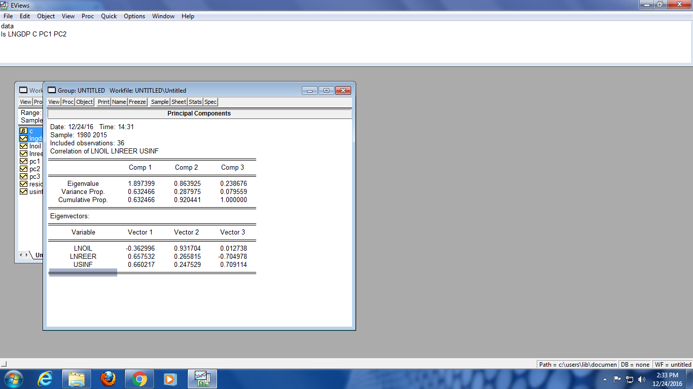

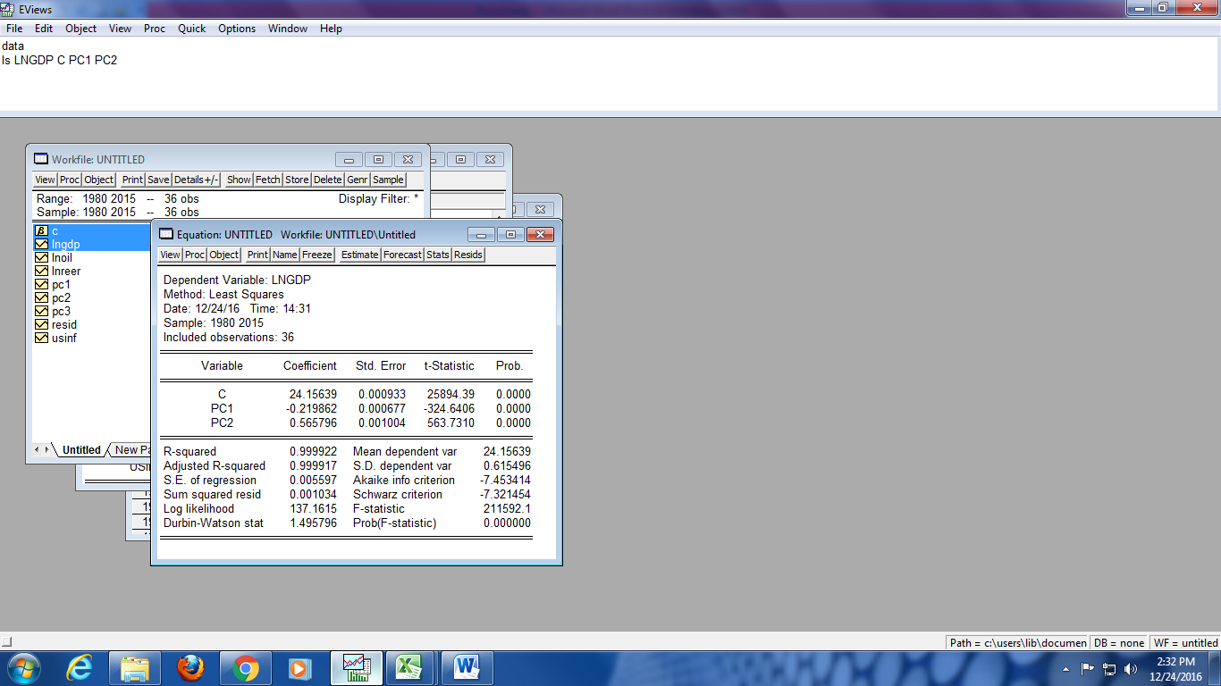

By applying the Newey-West method we can observe that the standard errors of the model getting better but probability of t-statics shows insignificancy between the dependent and independent variables. Therefore we applied principal component to remove the problem of multicollinarity, which represents the positive results.

## 5. Conclusion:

The objective of this research to find the relationship between the crude oil prices, real effective exchange rate and global inflation on GDP growth of Pakistan, throughout the research the variables shows the mix results on different tests, by applying SLRM-Simple regression model the result shows the significant relationship between the crude oil and GDP growth of Pakistan, on other hand REER and Inflation shows insignificant relationship with the GDP.

By analyzing the data, indicates that Pakistan imports of oil is a massive burden for the economy, The results described as the positive shocks will have positive results and negative shocks will have negative results, therefore decrease in oil prices brings always boost for the economy of Pakistan. the imports of both petroleum products and crude increased during the fiscal as consumption increased possibly due to lower petroleum prices in the local market also the insignificancy of inflation and exchange rate implies that in Pakistan the inflation an exchange rate are not directly effaced with the GDP growth, it sets on the basis of the annual or commutative impact of the economy.

**6. References:**

**Pakistan & Interaction between Sharp Rise in Oil Prices and Economic Growth of Pakistan ( 2014 )** Muhammad Waqas Chughtai and Munir Hussain Kazmi, (The International Journel, Volume 4, December 2014) School of Management Sciences, National Textile Institute Islamabad

**Sharp rise in oil prices on economy** (1988)[Glen L. Urban](http://pubsonline.informs.org/action/doSearch?text1=Urban%2C+Glen+L&field1=Contrib) Alfred P. Sloan School of Management, Massachusetts Institute of Technology, Cambridge, Massachusetts 02139 (june 1988)

**A comparison of the effects of exogenous oil supply shocks on output and inflation in the g7 countries (Mar, 2008)** Lutz Kilian (Journal of the European Economic Association) 1971-2004

**The Impact of Oil Price Shocks on the Economic Growth of Selected MENA Countries (2010)** M. Hakan Berument, Nildag Basak Ceylan and Nukhet Dogan (The Energy Journal)

**Impact of Increase in Oil Prices on Inflation and Output in India (Dec. 21, 2001)** Kaushik Bhattacharya and Indranil Bhattacharyya (Economic and Political Weekly)

**The Effects of Oil Price Shocks on Economic Growth of Oil Exporting Countries: A Case of Six OPEC Economies(2014)** Monesa , Laila Taskeen Qazi

**Impact of High Oil Prices on Pakistan’s Economic Growth** Adiqa Kiani (2010) (International Journal of Business and Social Science)

**Oil Price and Real GDP Growth in Pakistan (2014)** Bushra Sultan and Muhammad Waqas (Middle-East Journal of Scientific Research)

**Impact of Oil Price Increases on U.S. Economic Growth: Causality Analysis and Study of the Weakening Effects in Relationship (2012)** Sahbi FARHANI (International Journal of Energy Economics and Policy)

**The Interaction between Oil Price and Economic Growth (2011)** Latife Ghalayini (Middle Eastern Finance and Economics)

**Macroeconomic Effects of Oil Price Fluctuations on Emerging and Developed Economies in a Model Incorporating Monetary Variables (October 2015)** Farhad Taghizadeh-Hesary and Naoyuki Yoshino (Asian Development Bank Institute working Paper Series)

**Oil prices shocks and real GDP growth (May 2004)** Rebeca Jiménez-Rodríguez and Marcelo Sánchez

**Annexure A:**

|  |  |  |  |  |  |  |  |  |
| --- | --- | --- | --- | --- | --- | --- | --- | --- |
| **S:No** | **Title & date of publication** | **Author(s) & source** | **Sample size (time period)** | **Methodology** | **Model (Dependent variable)** | **Model (Independent variables)** | **Results** |  |
| 1 | **Oil prices shocks and real GDP growth**  **(May 2004)** | Rebeca Jiménez-Rodríguez and Marcelo Sánchez | 1971 -2000 | Liner and non liner regression model  Static test, unit root test | GDP Growth rate | Oil Prices | Oil prices has a negative /positive both the impacts on the differed countries |  |
| 2 | **Macroeconomic Effects of Oil Price Fluctuations on Emerging and Developed Economies in a Model Incorporating Monetary Variables**  **(October 2015)** | Farhad Taghizadeh-Hesary and Naoyuki Yoshino  (Asian Development Bank Institute working Paper Series) | 1960-2012  And  1990-2013 | n N-variable structural vector autoregression (SVAR) model  Cobb Doglars funtion | GDP and CPI | Crude Oil Prices | GDP growth rates in developed oil importers (US and Japan) are much milder than for an emerging economy’s like china |  |
| 3 | **The Interaction between Oil Price and Economic Growth**  **(2011)** | Latife Ghalayini  (Middle Eastern Finance and Economics) | 1986-2010 | Granger Causality tests | Economic Growth | Oil Prices | there is not a clear relationship between oil price and world economic growth |  |
| 4 | **Impact of Oil Price Increases on U.S. Economic Growth: Causality Analysis and Study of the Weakening Effects in Relationship**  **(2012)** | Sahbi FARHANI  (International Journal of Energy Economics and Policy) | 1960-2009 | simple linear regression model (SLRM), dynamic regression model (DRM) and VAR model,  Granger causality test | Economic /GDP Growth | Oil Prices | SLRM (Simple Linear Regression Model) and DRM (Dynamic regression model) presents a non significant coefficients or a bad adjustment in the direct relationship  While **vector error correction model (VECM**), shows a significant relationship between two factors. |  |
| 5 | **Oil Price and Real GDP Growth in Pakistan**  **(2014)** | Bushra Sultan and Muhammad Waqas  (Middle-East Journal of Scientific Research) | 1980-2012 | Johnson Co integration and error correction method | GDP Growth of Pakistan | Oil Prices | Oil Prices Negatively impact on GDP Growth of Pakistan |  |
| 6 | **Impact of High Oil Prices on Pakistan’s Economic Growth** | Adiqa Kiani  (International Journal of Business and Social Science) | 1990-2008 | Romar and Taylor Macroeconomic model also used open economy IS function and Augmented Philip Curve | Pakistan Economy/Real GDP | Higher Oil Price and inflation | real crude oil price effects the real GDP positively |  |
| 7 | **The Effects of Oil Price Shocks on Economic Growth of Oil Exporting Countries: A Case of Six OPEC Economies**  **(2014)** | Monesa , Laila Taskeen Qazi | 1980-2013 | uses Augmented Dickey Fuller (ADF) to establish Stationary of the time series and applies Vector Autoregressive (VARX) model with Ordinary Least Squares (OLS) model | Real GDP/Inflation/Exchange rate | Oil Prices | significant negative impact of oil shock on GDP growth of Algeria, a statistically significant positive impact of oil price shock on GDP growth of Venezuela, a statistically significant positive impact of oil shock on inflation rate of Iran and a statistically significant negative impact of oil shock on inflation rate of Venezuela, insignificant impact for other countries |  |
| 8 | **A COMPARISON OF THE EFFECTS OF EXOGENOUS OIL SUPPLY SHOCKS ON OUTPUT AND INFLATION IN THE G7 COUNTRIES**  **(Mar, 2008)** | Lutz Kilian  (Journal of the European Economic Association) | 1971-2004 | Liner regression model  Exogenous and dummy variables are also used | Crude oil Prices | Real GDP | no linear causal relationship between oil prices and macroeconomic aggregate(An exogenous oil supply disruption typically causes a temporary reduction in real GDP) |  |
| 9 | **The Impact of Oil Price Shocks on the Economic Growth of Selected MENA Countries**  **(2010)** | M. Hakan Berument, Nildag Basak Ceylan and Nukhet Dogan  (The Energy Journal) | 1969-2003 and 1972-2004 | Vector auto regression (VAR) | Output Growth | Crude Oil Prices | output decreases with positive oil supply shocks but output increases with positive oil demand shocks |  |
| 10 | **Impact of Increase in Oil Prices on Inflation and Output in India**  **(Dec. 21, 2001)** | Kaushik Bhattacharya and Indranil Bhattacharyya  (Economic and Political Weekly) | 1995-2000 | linear multiple time series | Commodities and output | Oil Prices | Rise in oil prices begins to affect the prices of other commodities and |  |